* * * * * * * * *
* *
* *
* *
* *
* *
* *
* *
* * * * * * * * *

class Main {
public static void main(String[] args) {
int i,j;
int n=9;

for(i=1;i<=n;i++){
for(j=1;j<=n;j++){
if(i==1 || i==9 || j==1 || j==9){
System.out.print("* ");
}
else{
System.out.print(" ");
}
}
System.out.println();
}
}
}

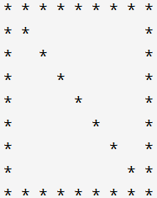

class Main {
public static void main(String[] args) {
int i,j;
int n=9;

for(i=1;i<=n;i++){
for(j=1;j<=n;j++){
if(i==1 || i==9 || j==1 || j==9 || i==j){
System.out.print("* ");
}
else{
System.out.print(" ");
}
}
System.out.println();
}
}
}
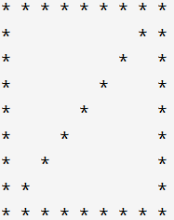

class Main {
public static void main(String[] args) {
int i,j;
int n=9;

for(i=1;i<=n;i++){
for(j=1;j<=n;j++){
if(i==1 || i==9 || j==1 || j==9 || i+j==n+1){
System.out.print("* ");
}
else{
System.out.print(" ");
}
}
System.out.println();
}
}
}
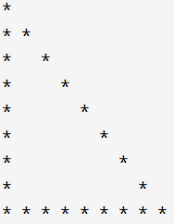

class Main {
public static void main(String[] args) {
int i,j;
int n=9;

for(i=1;i<=n;i++){
for(j=1;j<=n;j++){
if(j==1 || i==9 || i==j){
System.out.print("* ");
}
else{
System.out.print(" ");
}
}
System.out.println();
}
}
}
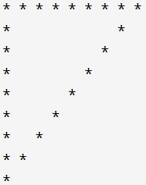

class Main {
public static void main(String[] args) {
int i,j;
int n=9;

for(i=1;i<=n;i++){
for(j=1;j<=n;j++){
if(j==1 || i==1 || i+j==n+1){
System.out.print("* ");
}
else{
System.out.print(" ");
}
}
System.out.println();
}
}
}
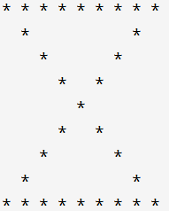

class Main {
public static void main(String[] args) {
int i,j;
int n=9;

for(i=1;i<=n;i++){
for(j=1;j<=n;j++){
if(i==1 || i==9 || i==j || i+j==n+1){
System.out.print("* ");
}
else{
System.out.print(" ");
}
}
System.out.println();
}
}
}
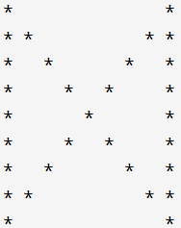

class Main {
public static void main(String[] args) {
int i,j;
int n=9;

for(i=1;i<=n;i++){
for(j=1;j<=n;j++){
if(j==1 || j==9 || i==j || i+j==n+1){
System.out.print("* ");
}
else{
System.out.print(" ");
}
}
System.out.println();
}
}
}
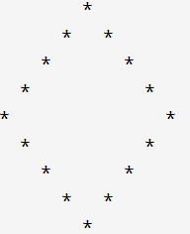

class Main {
public static void main(String[] args) {
int i,j;
int n=9;

for(i=1;i<=n;i++){
for(j=1;j<=n;j++){
if(i+j==n+1-4 || i==j+4 || i+j==n+1+4 || i==j-4){
System.out.print("* ");
}
else{
System.out.print(" ");
}
}
System.out.println();
}
}
}

